# Install OLED Screen SH1106

# Connecting the display

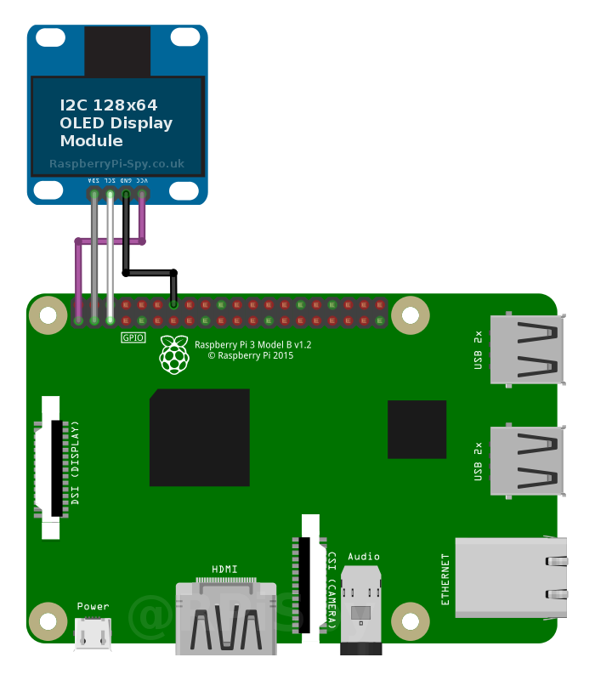

For the Pi4 its the same wiring!

# Enable I2C Interface

sudo raspi-config

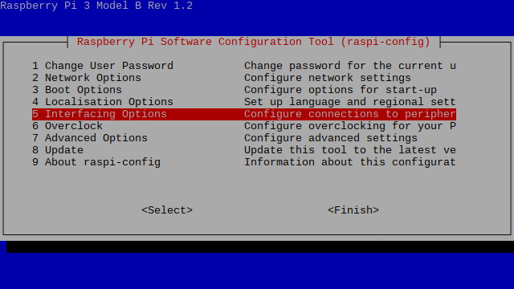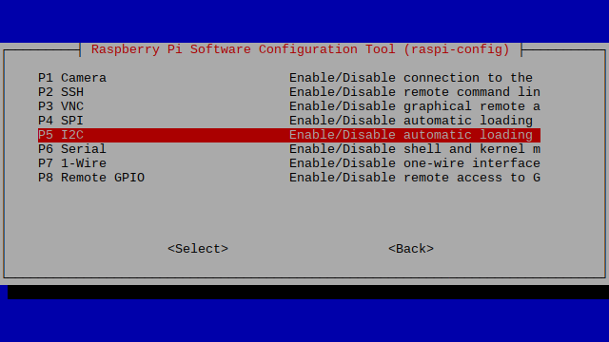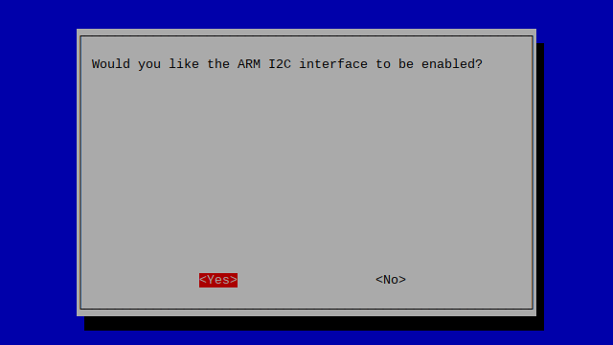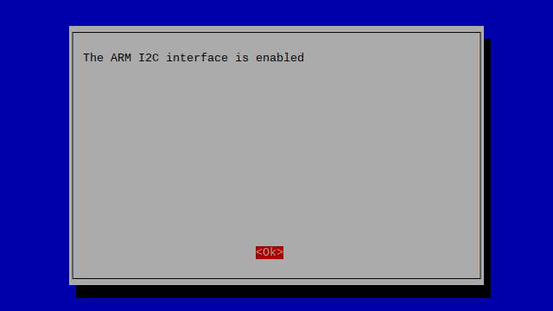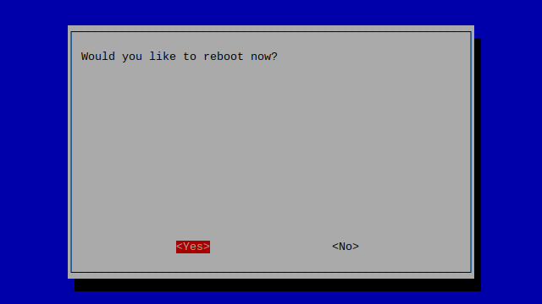

# Installing the dependencies

sudo apt update

sudo apt upgrade

sudo apt-get install -y python3 python3-dev python-smbus i2c-tools python3-pil python3-pip python3-setuptools python3-rpi.gpio libjpeg-dev zlib1g-dev libfreetype6-dev liblcms2-dev libopenjp2-7 libtiff5 git python3-gpiozero python3-imaging

sudo -H pip3 install luma.oled

sudo usermod -a -G spi,gpio,i2c pi

# Downloading the fonts/scripts

sudo mkdir /stats

cd /stats

sudo wget <https://github.com/freddy2312/SH1106-PiHole-Statistics/blob/main/Raspi-Schrift.ttf?raw=true>

sudo wget <https://github.com/freddy2312/SH1106-PiHole-Statistics/blob/main/VCR_OSD_MONO_1.001.ttf?raw=true>

sudo wget <https://raw.githubusercontent.com/freddy2312/SH1106-PiHole-Statistics/main/stats.py>

sudo wget <https://raw.githubusercontent.com/freddy2312/SH1106-PiHole-Statistics/main/launcher.sh>

sudo chmod 766 /stats/*

# Make it run at startup

sudo crontab –e

**Add at the bottom:**

@reboot /stats/launcher.sh > /stats/launcher.log 2>&1